**Submitted by – Sanket Bollamwar**

**Assignment on Collection Framework**

[**Q1**](https://adapt.in.capgemini.com/mod/vpl/view.php?id=2148)**. Write a class Person having weight, height & name. Create multiple person objects & print them in the sorted order. In the sorting order first sort based upon their weight & it two persons have same weight them sort them based upon their height. Use TreeSet.**

**Description: -** Create Person class with variables weight and height.Create multiple person objects & print them in the sorted order based upon weight first if the weights are equal then based upon height. Use TreeSet.

**Specifications:**

class Person{  
    private String name;  
    private int height;  
    private double weight;  
}  
  
public class Assignment3Q1 {  
    public static void main(String[] args) {}

}

**Code:**

import java.util.Comparator;

import java.util.Set;

import java.util.TreeSet;

class Person{

    String name;

    int height;

    double weight;

    public Person(String name, int height, double weight) {

        this.name = name;

        this.height = height;

        this.weight = weight;

    }

    @Override

    public String toString() {

        return "Name = "+this.name+"| Height = "+this.height+"| Weight = "+this.weight;

    }

}

class HeightComparator implements Comparator<Person>{

    @Override

    public int compare(Person o1, Person o2) {

        if(o1.weight>o2.weight){

            return -1;

        }

        else if(o1.weight<o2.weight){

            return 1;

        }

        else {

            return Double.compare(o2.height, o1.height);

        }

    }

}

public class Assignment5Q1 {

    public static void main(String[] args) {

        Set<Person> set = new TreeSet<>(new HeightComparator());

        set.add(new Person("Ayush Agrawal",165,70.5));

        set.add(new Person("Ritik Dixit",167,63.8));

        set.add(new Person("Pratik Nandurkar",172,80.9));

        set.add(new Person("Ujjwal Kohli",162,50.5));

        set.add(new Person("Harsh Vardhan Singh",170,50.5));

        set.add(new Person("Atharva Upadhye",162,51.5));

        set.add(new Person("Aryan Dewangan",162,53.5));

        System.out.println("Printing in the sorted order based upon weight first, if the weights are equal then based upon height:");

        for (Person person: set){

            System.out.println(person);

        }

    }

}

**Output:**

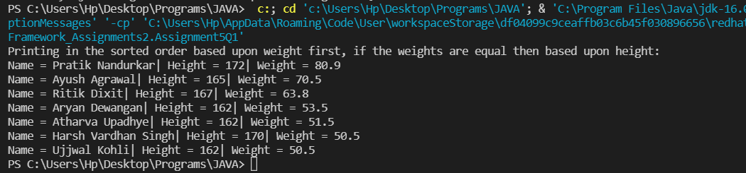

[**Q2**](https://adapt.in.capgemini.com/mod/vpl/view.php?id=2156)**.  Prove that Hash Set is unordered & Linked Hash Set is ordered.**

**Specifications:**

public class Assignment3Q2 {  
    public static void main(String[] args) { }  
    public static LinkedHashSet ordered(LinkedHashSet linkedHashSet){ }  
    public static HashSet unordered(HashSet hashSet){}

**}**

**Code:**

package Collection_Framework_Assignments2;

import java.util.HashSet;

import java.util.LinkedHashSet;

import java.util.Set;

public class Assignment5Q2 {

    public static HashSet<Integer> unordered(HashSet<Integer> hashSet){

        hashSet.add(3);

        hashSet.add(4);

        hashSet.add(1);

        hashSet.add(5);

        hashSet.add(2);

        return hashSet;

    }

    public static LinkedHashSet<Integer> ordered(LinkedHashSet<Integer> linkedHashSet){

        linkedHashSet.add(4);

        linkedHashSet.add(5);

        linkedHashSet.add(1);

        linkedHashSet.add(2);

        linkedHashSet.add(3);

        return linkedHashSet;

    }

    public static void main(String[] args) {

        Set<Integer> hashSet = new HashSet<>();

        Set<Integer> linkedHashSet = new LinkedHashSet<>();

        hashSet = unordered((HashSet<Integer>) hashSet);

        linkedHashSet = ordered((LinkedHashSet<Integer>) linkedHashSet);

        System.out.println("Elements in HashSet: ");

        for(Object i:hashSet){

            System.out.print(i+" ");

        }

        System.out.println("\nSee in HashSet the order in which the elements are inserted is not maintained ");

        System.out.println("\nElements in LinkedHashSet: ");

        for(int i:linkedHashSet){

            System.out.print(i+" ");

        }

        System.out.println("\nSee in LinkedHashSet the order in which the elements are inserted is maintained ");

    }

}

**Output:**

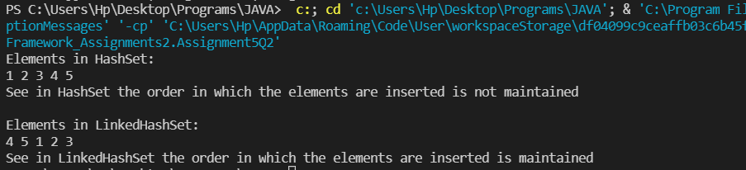

[**Q3**](https://adapt.in.capgemini.com/mod/vpl/view.php?id=2261)**. Create a ArrayList with few elements & print it in backward direction. Use ListIterator.**

**Description:**

Write a program which consists of ArrayList which has some elements and print them in reverse direction.

**Specifications:**

public class Assignment3Q3 {  
    public static List traverseReverse(ArrayList aList){}  
    public static void main(String[] args) {}  
}

**Code:**

package Collection_Framework_Assignments2;

import java.util.ArrayList;

import java.util.Collections;

public class Assignment5Q3 {

    public static ArrayList traverseReverse(ArrayList aList){

        Collections.reverse(aList);

        return aList;

    }

    public static void main(String[] args) {

        ArrayList<Integer> arrayList = new ArrayList<>();

        arrayList.add(1);

        arrayList.add(2);

        arrayList.add(3);

        arrayList.add(4);

        arrayList.add(5);

        arrayList.add(6);

        arrayList.add(7);

        arrayList.add(8);

        arrayList.add(9);

        arrayList.add(10);

        System.out.println("Printing Original Array: ");

        for (int i:arrayList){

            System.out.print(i+" ");

        }

        System.out.println("\nPrinting Reverse Array: ");

        arrayList = traverseReverse(arrayList);

        for (int i:arrayList){

            System.out.print(i+" ");

        }

    }

}

**Output:**

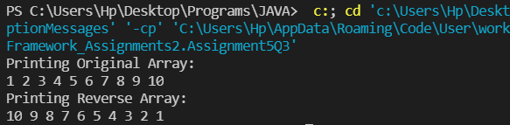

[**Q4**](https://adapt.in.capgemini.com/mod/vpl/view.php?id=2262)**. Write a program using Hashtable or HashMap where Date of birth is a key & Employee name as value. Design the class Date is such a way where the get method fails if two employees have same day & month of birth but birth year is different**.

**Description:-**

Using hash table or hash map write a program where key is date of birth and employee name is value and also the condition in the question should be satisfied.

**Specifications:**

class DateClass {  
    private int date;  
    private int month;  
    private int year;  
}  
  
public class Assignment3Q4 {  
  
    public String getEmployee(HashMap<DateClass, String> dob,String employeeName){}  
    public static void main(String[] args) {}  
}

**Code:**

import java.util.HashMap;

import java.util.Map;

import java.util.Objects;

class DateClass{

int date;

        int month;

        int year;

        public DateClass(int date, int month, int year) {

                this.date = date;

                this.month = month;

                this.year = year;

        }

        public int getDate() { return date; }

        public void setDate(int date) { this.date = date;}

        public int getMonth() { return month;}

        public void setMonth(int month) { this.month = month;}

        public int getYear() { return year;}

        public void setYear(int year) { this.year = year;}

        @Override

        public boolean equals(Object o) {

                if (this == o) return true;

                if (!(o instanceof DateClass)) return false;

                DateClass dateClass = (DateClass) o;

                return date == dateClass.date && month == dateClass.month || year == dateClass.year;

        }

        @Override

        public int hashCode() {

                return Objects.hash(date, month, year);

        }

        @Override

        public String toString() {

                return "Date = "+this.date+"  Month = "+this.month+"  Year = "+this.year;

        }

}

public class Assignment5Q4{

        public static void main(String[] args) {

                Map<DateClass,String> map = new HashMap<>();

                DateClass d1 = new DateClass(01,04,2001);

                DateClass d2 = new DateClass(02,03,2001);

                DateClass d3 = new DateClass(12,06,2000);

                map.putIfAbsent(d1,"Sanket Bollamwar");

                map.putIfAbsent(d2,"Prajwali Sukhadeve");

                map.putIfAbsent(d3,"Atul Singh");

                System.out.println("Key-value pair in HashMap: ");

                for(Map.Entry<DateClass,String> m:map.entrySet()){

                        DateClass key = m.getKey();

                        String value = m.getValue();

                        System.out.println(key+" : "+value);

                }

        }

}

**Output:**

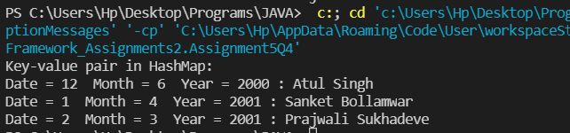

[**Q5**](https://adapt.in.capgemini.com/mod/vpl/view.php?id=2153)**. Write a user defined class say Employee that overrides equals() & hashCode() methods. Equals() always returns true & hashCode() always returns a fixed number. Make such a class as key of you Hashtable. Observe the behavior while calling put & get methods.**

**Description:-**

HashMap and HashSet use the hashcode value of an object to find out how the object would be stored in the collection, and subsequently hashcode is used to help locate the object in the collection. Hashing retrieval involves:

First, find out the right bucket using hashCode().

Secondly, search the bucket for the right element using equals().

**Specifications:**

class Employee {  
    private String name;  
    private int id;  
}  
  
public class Assignment3Q5 {  
    public static void main(String[] args) {}  
}

**Code:**

package Collection_Framework_Assignments2;

import java.util.HashMap;

import java.util.Map;

import java.util.Objects;

class employee{

    String name;

    int id;

    public String getName() { return name; }

    public int getId() { return id; }

    public employee(int id, String name) {

        this.name = name;

        this.id = id;

    }

    @Override

    public String toString() {

        return "Id = "+this.id+"  Name = "+this.name;

    }

    @Override

    public boolean equals(Object o) {

        if (this == o) return true;

        if (!(o instanceof employee)) return false;

        employee employee = (employee) o;

        return id == employee.id;

    }

    @Override

    public int hashCode() {

        return Objects.hash(id);

    }

}

public class Assignment5Q5 {

    public static void main(String[] args) {

        Map<Integer,String> map = new HashMap<>();

        employee e1 = new employee(1,"Sanket Bolllamwar");

        employee e2 = new employee(1,"Radha Sharma");

        employee e3 = new employee(3,"Pratik Chauhan");

        employee e4 = new employee(3,"Prajwali Sukhadeve");

        employee e5 = new employee(2,"Pratik Gupta");

        map.put(e1.getId(), e1.getName());

        map.put(e2.getId(), e2.getName());

        map.put(e3.getId(), e3.getName());

        map.put(e4.getId(), e4.getName());

        map.put(e5.getId(), e5.getName());

        System.out.println("Key-Value pair in map: ");

        for (Map.Entry<Integer,String> m:map.entrySet()){

            int key = m.getKey();

            String  value = m.getValue();

            System.out.println(key+" : "+value);

        }

    }

}

**Output:**

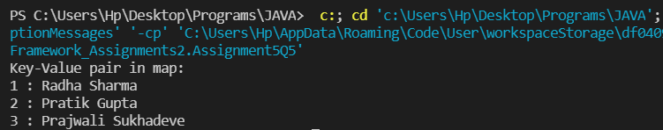

[**Q6**](https://adapt.in.capgemini.com/mod/vpl/view.php?id=2145)**. Implement the console based chatting using collections. Here are the options to be placed for to the user:**

**>java ChatApplication**

**Options:**

**A) Create a chatroom**

**B) Add the user**

**C) User login**

**D) Send a message**

**E) Display the messages from a specific chatroom**

**F) List down all users belonging to the specified chat room.**

**G) Logout**

**H) Delete an user**

**I) Delete the chat room.**

**Please enter your option:**

**Specifications:**

class Chatroom{  
    private String name;  
    private Set<String> username;  
    private List<String> messages;  
  
    {  
        name = "";  
        username = new HashSet<String>();  
        messages = new ArrayList<String>();  
    }  
    public boolean removeUser(String username) {  
    }  
}  
  
class User{  
  
    private String username;  
    private String password;  
    private String firstName;  
    private String lastName;  
}  
  
  
class ChatApplication{  
  
    private Map<String, Chatroom> chatrooms = new HashMap<String, Chatroom>();  
    private Map<String, User> users = new HashMap<String, User>();  
    private Set<String> loggedInUsers = new HashSet<String>();  
  
    public boolean isChatroomNameValid(String name) {}  
  
    public boolean isUsernameExists(String username) {}  
  
    public boolean authenticateUser(String username, String password) {}  
  
    //UI Methods Below  
    public void createChatroom() {}  
  
    public void addNewUser() {}  
  
    public boolean login() {}  
  
    public void sendMessage() {}  
    public void printMessages() {}  
  
    public void listUsersFromChatroom() {}  
  
    public void logout(){}  
  
    public void deleteUser(){}  
  
  
    public void menu() {}  
}  
  
public class Assignment3Q6{  
    public static void main(String[] args){}

**Code:**

package Collection_Framework_Assignments2;

import java.util.*;

class Chatroom{

    String name;

    Set<String> username;

    List<String> messages;

    public String getName() {

        return name;

    }

    public Set<String> getUsername() {

        return username;

    }

    public List<String> getMessages() {

        return messages;

    }

    Chatroom(){

        this.name = "";

        this.username = new HashSet<String>();

        this.messages = new ArrayList<String>();

    }

    @Override

    public boolean equals(Object o) {

        if (this == o) return true;

        if (!(o instanceof Chatroom)) return false;

        Chatroom chatroom = (Chatroom) o;

        return username.equals(chatroom.username);

    }

    @Override

    public int hashCode() {

        return Objects.hash(username);

    }

    public boolean removeUser(String username) {

        if(this.username.contains(username)){

            this.username.remove(username);

            return true;

        }

        return false;

    }

}

class User{

    String username;

    String password;

    String firstName;

    String lastName;

    public User(){

        username = "";

        password = "";

        firstName = "";

        lastName = "";

    }

    public User(String username, String password, String firstName, String lastName) {

        this.username = username;

        this.password = password;

        this.firstName = firstName;

        this.lastName = lastName;

    }

    public String getUsername() {

        return username;

    }

    public void setUsername(String username) {

        this.username = username;

    }

    public String getPassword() {

        return password;

    }

    public void setPassword(String password) {

        this.password = password;

    }

    public String getFirstName() {

        return firstName;

    }

    public void setFirstName(String firstName) {

        this.firstName = firstName;

    }

    public String getLastName() {

        return lastName;

    }

    public void setLastName(String lastName) {

        this.lastName = lastName;

    }

    @Override

    public boolean equals(Object o) {

        if (this == o) return true;

        if (!(o instanceof User)) return false;

        User user = (User) o;

        return username.equals(user.username);

    }

    @Override

    public int hashCode() {

        return Objects.hash(username);

    }

}

class ChatApplication{

    Map<String, Chatroom> chatrooms = new HashMap();

    Map<String, User> users = new HashMap();

    Set<String> loggedInUsers = new HashSet();

    int chatroomCount = 0;

    int userCount = 0;

    public boolean isChatroomNameValid(String name) {

       for (Map.Entry<String,Chatroom> mp: chatrooms.entrySet()){

           Chatroom chatroom = mp.getValue();

           if(chatroom.name.equals(name)){

               return true;

           }

       }

       return false;

    }

    public boolean isUsernameExists(String username) {

        for(Map.Entry<String, User> mp: users.entrySet()){

            User user = mp.getValue();

            if(user.username.equals(username)){

                return true;

            }

        }

        return false;

    }

    public boolean authenticateUser(String username, String password) {

        for(Map.Entry<String, User> mp: users.entrySet()){

            User user = mp.getValue();

            if(user.username.equals(username) && user.password.equals(password)){

                return true;

            }

        }

        return false;

    }

    //UI Methods Below

    public void createChatroom() {

        Chatroom chatroom = new Chatroom();

        chatroom.messages = new ArrayList<>();

        chatroom.username = new HashSet<>();

        Scanner sc = new Scanner(System.in);

        System.out.print("Enter the chatroom name: ");

        chatroom.name = sc.nextLine();

        System.out.print("Enter the chatroom username: ");

        chatroom.username.add(sc.nextLine());

        System.out.print("Enter the chatroom message: ");

        chatroom.messages.add(sc.nextLine());

        System.out.println(chatroom.getName());

        System.out.println(chatroom.getUsername());

        System.out.println(chatroom.getMessages());

        //Adding the message in map.

        chatrooms.put(Integer.toString(chatroomCount+1),chatroom);

        chatroomCount+=1;

    }

    public void addNewUser() {

        User user = new User();

        Scanner sc = new Scanner(System.in);

        System.out.print("Enter the first name: ");

        user.setFirstName(sc.nextLine());

        System.out.print("Enter the last name: ");

        user.setLastName(sc.nextLine());

        System.out.print("Enter the username: ");

        user.setUsername(sc.nextLine());

        System.out.print("Enter the password: ");

        user.setPassword(sc.nextLine());

        //Adding user in map

        users.put(Integer.toString(userCount+1),user);

        userCount +=1;

    }

    public boolean login() {

        User user = new User();

        Scanner sc = new Scanner(System.in);

        String username, password;

        System.out.print("Enter the username: ");

        username = sc.next();

        System.out.println("Enter the password: ");

        password = sc.next();

        if(user.username.equals(username) && user.password.equals(password)){

            System.out.println("LOGIN SUCCESSFUL");

            loggedInUsers.add(user.username);

            return true;

        }

        return false;

    }

    public void sendMessage() {

        Scanner sc = new Scanner(System.in);

        System.out.print("Enter the Message: ");

        String message = sc.next();

        System.out.println("Message has been sent successfully!");

        System.out.println("Message is: "+message);

    }

    public void printMessages() {

        for (Map.Entry<String,Chatroom> mp: chatrooms.entrySet()){

            Chatroom chatroom = mp.getValue();

            System.out.println("Username: "+chatroom.username);

            System.out.println("Message: "+chatroom.messages);

        }

    }

    public void listUsersFromChatroom() {

        System.out.println("All the users from the chatroom");

        for(Map.Entry<String ,Chatroom> mp: chatrooms.entrySet()){

            Chatroom chatroom = mp.getValue();

            System.out.println("username: "+chatroom.name);

        }

    }

    public void logout(){

        System.out.println("LOGOUT SUCCESSFULLY");

        System.exit(0);

    }

    public void deleteUser(){

        Scanner sc = new Scanner(System.in);

        System.out.print("Enter the username to be deleted: ");

        String username = sc.next();

        for (Map.Entry<String,User> mp: users.entrySet()){

            User user = mp.getValue();

            String key = "null";

            if(user.username.equals(username)){

                key = mp.getKey();

                break;

            }

            users.remove(key);

            System.out.println("User removed successfully!");

        }

    }

    public void deleteChatRoom(){

        Scanner sc = new Scanner(System.in);

        System.out.println("Enter the chatroom username to be deleted: ");

        String username = sc.next();

        for (Map.Entry<String,Chatroom> mp: chatrooms.entrySet()){

            Chatroom chatroom = mp.getValue();

            String key = "null";

            if(chatroom.username.equals(username)){

                key = mp.getKey();

                break;

            }

            users.remove(key);

            System.out.println("User removed successfully!");

        }

    }

    public void menu() {

        Scanner sc = new Scanner(System.in);

        int choice;

        do{

            System.out.println("1) Create a chatroom ");

            System.out.println("2) Add the user ");

            System.out.println("3) User login ");

            System.out.println("4) Send a message ");

            System.out.println("5) Display the messages from a specific chatroom ");

            System.out.println("6) List down all users belonging to the specified chat room. ");

            System.out.println("7) Delete an user ");

            System.out.println("8) Delete the chat room. ");

            System.out.println("9) Logout");

            System.out.println("Please enter your option:");

            choice = sc.nextInt();

            switch (choice){

                case 1: createChatroom();

                    System.out.println("ChatRoom Created Successfully!");

                    break;

                case 2: addNewUser();

                    System.out.println("New User Added Successfuly!");

                    break;

                case 3:

                    if(login()==false){

                        System.out.println("USERNAME OR PASSWORD IS INCORRECT PLEASE TRY AGAIN!");

                    }

                    break;

                case 4: sendMessage();

                break;

                case 5: printMessages();

                break;

                case 6: listUsersFromChatroom();

                break;

                case 7: deleteUser();

                break;

                case 8: deleteChatRoom();

                break;

                case 9: logout();

                break;

                default:

                    System.out.println("PLEASE ENTER THE RIGHT CHOICE!!");

            }

        }while(choice!=9);

    }

}

public class Assignment5Q6 {

    public static void main(String[] args) {

        ChatApplication chatApplication = new ChatApplication();

        chatApplication.menu();

    }

}

**Output:**

import java.util.*;

class Chatroom{

    String name;

    Set<String> username;

    List<String> messages;

    public String getName() { return name; }

    public Set<String> getUsername() { return username; }

    public List<String> getMessages() { return messages; }

    Chatroom(){

        this.name = "";

        this.username = new HashSet<String>();

        this.messages = new ArrayList<String>();

    }

    @Override

    public boolean equals(Object o) {

        if (this == o) return true;

        if (!(o instanceof Chatroom)) return false;

        Chatroom chatroom = (Chatroom) o;

        return username.equals(chatroom.username);

    }

    @Override

    public int hashCode() {

        return Objects.hash(username);

    }

    public boolean removeUser(String username) {

        if(this.username.contains(username)){

            this.username.remove(username);

            return true;

        }

        return false;

    }

}

class User{

    String username;

    String password;

    String firstName;

    String lastName;

    public User(){

        username = "";

        password = "";

        firstName = "";

        lastName = "";

    }

    public User(String username, String password, String firstName, String lastName) {

        this.username = username;

        this.password = password;

        this.firstName = firstName;

        this.lastName = lastName;

    }

    public String getUsername() {  return username;  }

    public void setUsername(String username) { this.username = username; }

    public String getPassword() { return password; }

    public void setPassword(String password) { this.password = password;}

    public String getFirstName() { return firstName; }

    public void setFirstName(String firstName) { this.firstName = firstName; }

    public String getLastName() { return lastName; }

    public void setLastName(String lastName) { this.lastName = lastName;  }

    @Override

    public boolean equals(Object o) {

        if (this == o) return true;

        if (!(o instanceof User)) return false;

        User user = (User) o;

        return username.equals(user.username);

    }

    @Override

    public int hashCode() {

        return Objects.hash(username);

    }

}

class ChatApplication{

    Map<String, Chatroom> chatrooms = new HashMap();

    Map<String, User> users = new HashMap();

    Set<String> loggedInUsers = new HashSet();

    int chatroomCount = 0;

    int userCount = 0;

    public boolean isChatroomNameValid(String name) {

       for (Map.Entry<String,Chatroom> mp: chatrooms.entrySet()){

           Chatroom chatroom = mp.getValue();

           if(chatroom.name.equals(name)){

               return true;

           }

       }

       return false;

    }

    public boolean isUsernameExists(String username) {

        for(Map.Entry<String, User> mp: users.entrySet()){

            User user = mp.getValue();

            if(user.username.equals(username)){

                return true;

            }

        }

        return false;

    }

    public boolean authenticateUser(String username, String password) {

        for(Map.Entry<String, User> mp: users.entrySet()){

            User user = mp.getValue();

            if(user.username.equals(username) && user.password.equals(password)){

                return true;

            }

        }

        return false;

    }

    //UI Methods Below

    public void createChatroom() {

        Chatroom chatroom = new Chatroom();

        chatroom.messages = new ArrayList<>();

        chatroom.username = new HashSet<>();

        Scanner sc = new Scanner(System.in);

        System.out.print("Enter the chatroom name: ");

        chatroom.name = sc.nextLine();

        System.out.print("Enter the chatroom username: ");

        chatroom.username.add(sc.nextLine());

        System.out.print("Enter the chatroom message: ");

        chatroom.messages.add(sc.nextLine());

        System.out.println(chatroom.getName());

        System.out.println(chatroom.getUsername());

        System.out.println(chatroom.getMessages());

        //Adding the message in map.

        chatrooms.put(Integer.toString(chatroomCount+1),chatroom);

        chatroomCount+=1;

    }

    public void addNewUser() {

        User user = new User();

        Scanner sc = new Scanner(System.in);

        System.out.print("Enter the first name: ");

        user.setFirstName(sc.nextLine());

        System.out.print("Enter the last name: ");

        user.setLastName(sc.nextLine());

        System.out.print("Enter the username: ");

        user.setUsername(sc.nextLine());

        System.out.print("Enter the password: ");

        user.setPassword(sc.nextLine());

        //Adding user in map

        users.put(Integer.toString(userCount+1),user);

        userCount +=1;

    }

    public boolean login() {

        User user = new User();

        Scanner sc = new Scanner(System.in);

        String username, password;

        System.out.print("Enter the username: ");

        username = sc.next();

        System.out.println("Enter the password: ");

        password = sc.next();

        if(user.username.equals(username) && user.password.equals(password)){

            System.out.println("LOGIN SUCCESSFUL");

            loggedInUsers.add(user.username);

            return true;

        }

        return false;

    }

    public void sendMessage() {

        Scanner sc = new Scanner(System.in);

        System.out.print("Enter the Message: ");

        String message = sc.next();

        System.out.println("Message has been sent successfully!");

        System.out.println("Message is: "+message);

    }

    public void printMessages() {

        for (Map.Entry<String,Chatroom> mp: chatrooms.entrySet()){

            Chatroom chatroom = mp.getValue();

            System.out.println("Username: "+chatroom.username);

            System.out.println("Message: "+chatroom.messages);

        }

    }

    public void listUsersFromChatroom() {

        System.out.println("All the users from the chatroom");

        for(Map.Entry<String ,Chatroom> mp: chatrooms.entrySet()){

            Chatroom chatroom = mp.getValue();

            System.out.println("username: "+chatroom.name);

        }

    }

    public void logout(){

        System.out.println("LOGOUT SUCCESSFULLY");

        System.exit(0);

    }

    public void deleteUser(){

        Scanner sc = new Scanner(System.in);

        System.out.print("Enter the username to be deleted: ");

        String username = sc.next();

        for (Map.Entry<String,User> mp: users.entrySet()){

            User user = mp.getValue();

            String key = "null";

            if(user.username.equals(username)){

                key = mp.getKey();

                break;

            }

            users.remove(key);

            System.out.println("User removed successfully!");

        }

    }

    public void deleteChatRoom(){

        Scanner sc = new Scanner(System.in);

        System.out.println("Enter the chatroom username to be deleted: ");

        String username = sc.next();

        for (Map.Entry<String,Chatroom> mp: chatrooms.entrySet()){

            Chatroom chatroom = mp.getValue();

            String key = "null";

            if(chatroom.username.equals(username)){

                key = mp.getKey();

                break;

            }

            users.remove(key);

            System.out.println("User removed successfully!");

        }

    }

    public void menu() {

        Scanner sc = new Scanner(System.in);

        int choice;

        do{

            System.out.println("1) Create a chatroom ");

            System.out.println("2) Add the user ");

            System.out.println("3) User login ");

            System.out.println("4) Send a message ");

            System.out.println("5) Display the messages from a specific chatroom ");

            System.out.println("6) List down all users belonging to the specified chat room. ");

            System.out.println("7) Delete an user ");

            System.out.println("8) Delete the chat room. ");

            System.out.println("9) Logout");

            System.out.println("Please enter your option:");

            choice = sc.nextInt();

            switch (choice){

                case 1: createChatroom();

                    System.out.println("ChatRoom Created Successfully!");

                    break;

                case 2: addNewUser();

                    System.out.println("New User Added Successfuly!");

                    break;

                case 3:

                    if(login()==false){

                        System.out.println("USERNAME OR PASSWORD IS INCORRECT PLEASE TRY AGAIN!");

                    }

                    break;

                case 4: sendMessage();

                break;

                case 5: printMessages();

                break;

                case 6: listUsersFromChatroom();

                break;

                case 7: deleteUser();

                break;

                case 8: deleteChatRoom();

                break;

                case 9: logout();

                break;

                default:

                    System.out.println("PLEASE ENTER THE RIGHT CHOICE!!");

            }

        }while(choice!=9);

    }

}

public class Assignment5Q6 {

    public static void main(String[] args) {

        ChatApplication chatApplication = new ChatApplication();

        chatApplication.menu();

    }

}

**Output:**

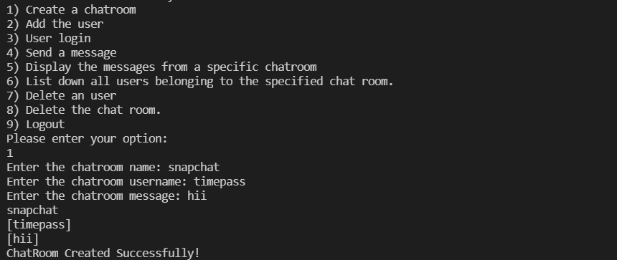

[**Q7**](https://adapt.in.capgemini.com/mod/vpl/view.php?id=2169)**. There is parking slot available in R-Mall with 3 floors; each floor has 4 sections and each section can maximum park 20 cars. You need to design one application which will maintain all car details in such way when a car owner arrives to collect his care your application should provide details including where it is located.**

**a. Create class Parked_CarOwner_Details which will have field’s owerName, carModel, carNO, owerMobileNo, owerAddress with setter and getter methods.**

**b. Create class Parked_CarOwenerList which will have method’s int add_new_car(Parked_CarOwner_Details obj), remove_car(), get_parked_car_location(token).**

**Specifications:**

class ParkingSlot {  
    private String ownerName;  
    private int carNumber;  
    private int token;  
    private int level;  
    private int section;  
    private int slot;  
}  
  
class Parked_CarOwenerList {  
    int levels = 3;  
    int sections = 4;  
    int slots = 20;  
    public void add_new_car(Assignment3Q7 obj){}  
    public void remove_car(String name,int carNo){}  
    public String get_parked_car_location(int token){}  
}  
  
public class Assignment3Q7 {  
    private String name;  
    private String carModel;  
    private int carNo;  
    private int mobileNumber;  
    private String address;

    public static void main(String[] args) {}

**Code:**

package Collection_Framework_Assignments2;

import java.util.HashMap;

import java.util.Map;

import java.util.Map.Entry;

import java.util.Scanner;

class ParkingSlot {

    private String ownerName;

    private int carNumber;

    private int token;

    private int level;

    private int section;

    private int slot;

    public String getOwnerName() {

        return ownerName;

    }

    public void setOwnerName(String ownerName) {

        this.ownerName = ownerName;

    }

    public int getCarNumber() {

        return carNumber;

    }

    public void setCarNumber(int carNumber) {

        this.carNumber = carNumber;

    }

    public void setLevel(int level) {

        this.level = level;

    }

    public int getSection() {

        return section;

    }

    public void setSection(int section) {

        this.section = section;

    }

    public int getSlot() {

        return slot;

    }

    public void setSlot(int slot) {

        this.slot = slot;

    }

}

class Parked_CarOwenerList extends Assignment5Q7{

    int id = 1;

    int levels = 3;

    int sections = 4;

    int slots = 20;

    Map<Integer,Assignment5Q7> car = new HashMap<>();

    Map<Integer,ParkingSlot> parkingSlotMap = new HashMap<>();

    public void add_new_car(Assignment5Q7 obj){

        Scanner sc = new Scanner(System.in);

        System.out.print("Enter the name of the owner of car: ");

        obj.setName(sc.nextLine());

        System.out.print("Enter the car model: ");

        obj.setCarModel(sc.nextLine());

        System.out.print("Enter the car number: ");

        obj.setCarNo(sc.nextInt());

        System.out.print("Enter the owner mobile number: ");

        obj.setMobileNumber(sc.nextInt());

        System.out.print("Enter the address: ");

        obj.setAddress(sc.nextLine());

        car.put(id,obj);

        id++;

        System.out.println("User Registered Successfully!");

    }

    public void remove_car(String name,int carNo){

        int key = 0;

        for (Map.Entry<Integer, Assignment5Q7> mp: car.entrySet()){

            Assignment5Q7 obj = mp.getValue();

            if(obj.getName().equals(name)&&obj.getCarNo()==carNo){

                key = mp.getKey();

                break;

            }

        }

        car.remove(key);

    }

    public String get_parked_car_location(int token){

        Scanner sc = new Scanner(System.in);

        ParkingSlot parkingSlot = new ParkingSlot();

        System.out.print("Enter the ownerName: ");

        parkingSlot.setOwnerName(sc.nextLine());

        System.out.print("Enter the car number: ");

        parkingSlot.setCarNumber(sc.nextInt());

        System.out.print("Enter the level: ");

        parkingSlot.setLevel(sc.nextInt());

        System.out.print("Enter the Section: ");

        parkingSlot.setLevel(sc.nextInt());

        System.out.print("Enter the Slot: ");

        parkingSlot.setSlot(sc.nextInt());

        parkingSlotMap.put(token,parkingSlot);

        return "CAR PARKED SUCCESSFULLY!";

    }

}

public class Assignment5Q7 {

   String name;

   String carModel;

    int carNo;

    int mobileNumber;

    String address;

    public String getName() {

        return name;

    }

    public void setName(String name) {

        this.name = name;

    }

    public void setCarModel(String carModel) {

        this.carModel = carModel;

    }

    public int getCarNo() {

        return carNo;

    }

    public void setCarNo(int carNo) {

        this.carNo = carNo;

    }

    public void setMobileNumber(int mobileNumber) {

        this.mobileNumber = mobileNumber;

    }

    public void setAddress(String address) {

        this.address = address;

    }

    public void menu(){

        Parked_CarOwenerList parked_carOwenerList = new Parked_CarOwenerList();

        Scanner sc = new Scanner(System.in);

        int choice;

        do{

            System.out.println("1) ADD NEW CAR");

            System.out.println("2) REMOVE CAR");

            System.out.println("3) PARK THE CAR");

            System.out.println("4) EXIT");

            System.out.println("ENTER YOUR CHOICE");

            choice = sc.nextInt();

            switch (choice){

                case 1: parked_carOwenerList.add_new_car(new Assignment5Q7());

                        break;

                case 2: String name;

                int number;

                    System.out.print("Enter the owner name: ");

                    name = sc.nextLine();

                    System.out.print("Enter the car number: ");

                    number = sc.nextInt();

                        parked_carOwenerList.remove_car(name,number);

                        break;

                case 3:

                    System.out.println(parked_carOwenerList.get_parked_car_location(101));

                    break;

                case 4:

                    System.exit(0);

                default:

                    System.out.println("PLEASE ENTER THE CORRECT CHOICE!!");

            }

        }while (choice!=4);

    }

    public static void main(String[] args) {

        Assignment5Q7 obj = new Assignment5Q7();

        obj.menu();

    }

}

**Output:**

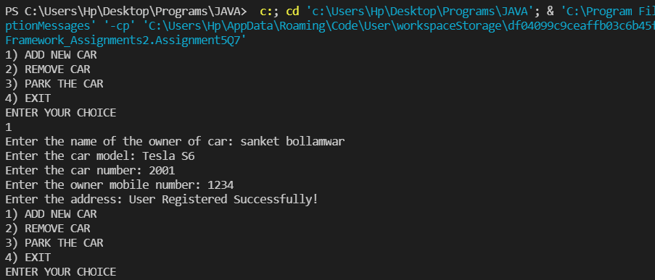

[**Q8**](https://adapt.in.capgemini.com/mod/vpl/view.php?id=2147)**.1.  Test fail-fast iterators within multithreaded environment. Note example of fail fast iterator is Vector, ArrayList, HashSet etc. And fail-safe is ConcurrentHashMap, CopyOnWriteArrayList etc.**

**Fail Fast:**

Iterators in java are used to iterate over the Collection objects.Fail-Fast iterators immediately throw ConcurrentModificationException if there is structural modification of the collection. Structural modification means adding, removing or updating any element from collection while a thread is iterating over that collection. Iterator on ArrayList, HashMap classes are some examples of fail-fast Iterator.

**Specifications:**

public class Assignment3Q8a {  
    public static void failFast(Map<String, String> cityCode){}  
    public static void main(String[] args) {}  
}

**Code:**

package Collection_Framework_Assignments2;

import java.util.HashMap;

import java.util.Iterator;

import java.util.Map;

public class Assignment5Q8A {

    public static void main(String[] args) {

        Map<String, String> cityCode = new HashMap<String, String>();

        cityCode.put("Delhi", "India");

        cityCode.put("Moscow", "Russia");

        cityCode.put("New York", "USA");

        Iterator iterator = cityCode.keySet().iterator();

        while (iterator.hasNext()) {

            System.out.println(cityCode.get(iterator.next()));

            cityCode.put("Istanbul", "Turkey");

        }

    }

}

**Output:**

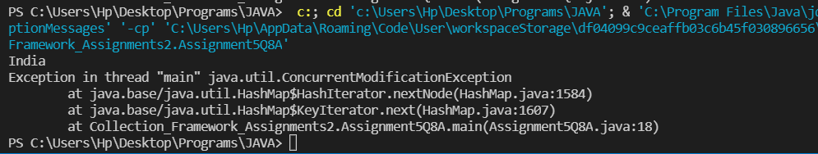

[**Q8**](https://adapt.in.capgemini.com/mod/vpl/view.php?id=2147)**.2. Test fail-safe iterators within multithreaded environment. Note example of fail fast iterator is Vector, ArrayList, HashSet etc. And fail-safe is ConcurrentHashMap, CopyOnWriteArrayList etc.**

**Fail Safe:**

Fail-Safe iterators don’t throw any exceptions if a collection is structurally modified while iterating over it. This is because, they operate on the clone of the collection, not on the original collection and that’s why they are called fail-safe iterators. Iterator on CopyOnWriteArrayList, ConcurrentHashMap classes are examples of fail-safe Iterator.

**Specifications:**

public class Assignment3Q8b {  
    public static CopyOnWriteArrayList<Integer> failFast(CopyOnWriteArrayList<Integer> list){  
    }  
    public static void main(String args[]) {}

**Code:**

package Collection_Framework_Assignments2;

import java.util.concurrent.CopyOnWriteArrayList;

import java.util.Iterator;

public class Assignment5Q8B {

    public static void main(String[] args) {

        CopyOnWriteArrayList<Integer> list

                = new CopyOnWriteArrayList<Integer>(new Integer[] { 1, 3, 5, 8 });

        Iterator itr = list.iterator();

        while (itr.hasNext()) {

            Integer no = (Integer)itr.next();

            System.out.println(no);

            if (no == 8)

                list.add(14);

        }

    }

}

**Output:**

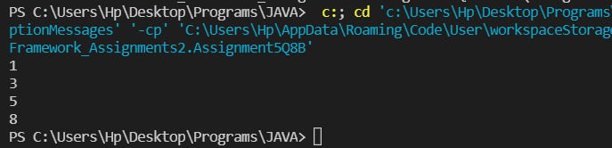

[**Q9**](https://adapt.in.capgemini.com/mod/vpl/view.php?id=2150)**. Create a Class SavingAccount with field’s acc_balance, acc_ID, accountHoldername, isSalaryAccount. Also add setter and getter methods with business method like withdraw and deposit.**

**a. Create class BankAccountList which will maintain SavingAccount objects. Ensure that this class should not allow duplicates as well as data should be displayed in sorted order. (as per acc_ID)**

**Specifications:**

class SavingAccount {  
  
    private double acc_balance;  
    private int acc_ID;  
    private String accountHolderName;  
    private boolean isSalaryAccount;  
}  
  
class BankAccountList{  
  
    private TreeSet<SavingAccount> savingAccounts = new TreeSet<>();  
  
    public boolean addSavingAccount(SavingAccount savingAccount) {}  
  
    public List<Integer> displaySavingAccountIds() {}  
}  
  
public class Assignment3Q9 {  
    public static void main(String[] args) {}

**Code:**

package Collection_Framework_Assignments2;

import java.util.*;

class savingaccount {

    private double acc_balance;

    private int acc_ID;

    private String accountHolderName;

    private boolean isSalaryAccount;

    public double getAcc_balance() {

        return acc_balance;

    }

    public void setAcc_balance(double acc_balance) {

        this.acc_balance = acc_balance;

    }

    public int getAcc_ID() {

        return acc_ID;

    }

    public void setAcc_ID(int acc_ID) {

        this.acc_ID = acc_ID;

    }

    public String getAccountHolderName() {

        return accountHolderName;

    }

    public void setAccountHolderName(String accountHolderName) {

        this.accountHolderName = accountHolderName;

    }

    public boolean isSalaryAccount() {

        return isSalaryAccount;

    }

    public void setSalaryAccount(boolean salaryAccount) {

        isSalaryAccount = salaryAccount;

    }

    public void withDraw(double amount){

        if(this.acc_balance<amount){

            System.out.println("YOUR ACCOUNT HAS INSUFFICIENT BALANCE");

        }

        else{

            this.acc_balance-=amount;

            System.out.println("MONEY WITHDRAWN SUCCESSFULLY");

            System.out.println("ACCOUNT BALANCE = "+this.acc_balance);

        }

    }

    public void Deposit(double amount){

        this.acc_balance += amount;

        System.out.println("MONEY ADDED SUCCESSFULLY");

        System.out.println("ACCOUNT BALANCE = "+this.acc_balance);

    }

}

class accountComparator implements Comparator<savingaccount>{

    @Override

    public int compare(savingaccount o1, savingaccount o2) {

        if(o1.getAcc_ID()>o2.getAcc_ID()){

            return -1;

        }

        else if(o1.getAcc_ID()<o2.getAcc_ID()){

            return 1;

        }

        else {

            return 0;

        }

    }

}

class BankAccountList{

    TreeSet<savingaccount> savingAccounts = new TreeSet<>(new accountComparator());

    public boolean addSavingAccount(savingaccount savingAccount) {

        Scanner sc = new Scanner(System.in);

        System.out.println("Enter the Account Id: ");

        savingAccount.setAcc_ID(sc.nextInt());

        System.out.println("Enter the Account holder name: ");

        savingAccount.setAccountHolderName(sc.next());

        System.out.println("Enter the Account Balance: ");

        savingAccount.setAcc_balance(sc.nextDouble());

        System.out.println("Is Saving Account (Yes/No): ");

        String accountType =  sc.next();

        if(accountType.toUpperCase().equals("YES")){

            savingAccount.setSalaryAccount(true);

        }

        else{

            savingAccount.setSalaryAccount(false);

        }

        savingAccounts.add(savingAccount);

        System.out.println("ACCOUNT REGISTERED SUCCESSFULLY");

        return true;

    }

    public List<Integer> displaySavingAccountIds() {

        List<Integer> id = new ArrayList<>();

        for(savingaccount savingaccount: savingAccounts){

            id.add(savingaccount.getAcc_ID());

        }

        return id;

    }

}

public class Assignment5Q9 {

    public static void main(String[] args) {

        BankAccountList bankAccountList = new BankAccountList();

        savingaccount savingaccount = new savingaccount();

        Scanner sc = new Scanner(System.in);

        int choice;

        do{

            System.out.println("1. ADD THE SAVING ACCOUNT");

            System.out.println("2. DEPOSIT MONEY");

            System.out.println("3. WITHDRAW MONEY");

            System.out.println("4. DISPLAY THE SAVING ACCOUNT IDs");

            System.out.println("ENTER YOUR CHOICE");

            choice = sc.nextInt();

            switch (choice){

                case 1: bankAccountList.addSavingAccount(savingaccount);

                    break;

                case 2:double amount;

                    System.out.println("Enter the amount to be deposit: ");

                    amount = sc.nextDouble();

                    savingaccount.Deposit(amount);

                    break;

                case 3:

                    double amount1;

                    System.out.println("Enter the amount to be withdraw: ");

                    amount1 = sc.nextDouble();

                    savingaccount.withDraw(amount1);

                    break;

                case 4: List<Integer> id = new ArrayList<>();

                    id = bankAccountList.displaySavingAccountIds();

                    System.out.println("Account Id: ");

                    for(Integer i: id){

                        System.out.println(i);

                    }

                    break;

                case 5: System.exit(0);

                default:

                    System.out.println("PLEASE ENTER THE VALID OPTION!");

            }

        }while (choice!=5);

    }

}

**Output:**

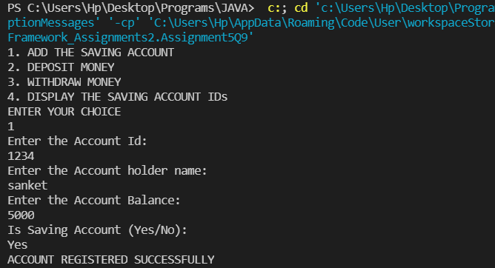

**Q10. Create class Movie_Details with field’s mov_Name, lead_actor, lead_actories, and genre add setter and getter method in that class.**

**a. After creating this class create class Movie_DetailsList class who will maintain all the objects.**

**b. Movie_DetailsList class should have method add_movie(), remove_movie(), remove_AllMovies(), find_movie_By_mov_Name(), find_movie_By_Genre()**

**c. Movie_DetailsList should have method which will take an argument that will be use to determine on which to sort**

**Specifications:**

class MovieDetails {  
    private String movieName;  
    private String actor;  
    private String actress;  
    private String genre;  
}  
  
public class Assignment3Q10 {  
    public static void main(String[] args) {}  
  
    public static void sort(ArrayList<MovieDetails> movieDetails,Comparator<MovieDetails> movieDetailsComparator){}  
  
    public static void printSortedMovieList(ArrayList<MovieDetails> movieDetails){}  
    public void addMovie(MovieDetails movie) {}  
  
    public void removeMovies(String movieName) {}  
  
    public void removeAllMovies(List<MovieDetails> movies) {}  
  
    public MovieDetails find_movie_By_mov_Name(String movieName) {}  
  
    public List<MovieDetails> find_movie_By_Genre(String genre) {}  
  
    public static Comparator<MovieDetails> sortAccordingly(String sortBy) {}

**}**

**Code:**